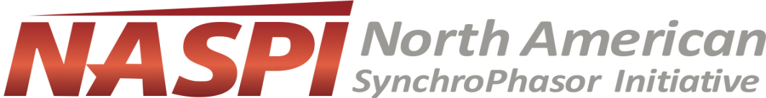
The 2019 NASPI Awards

Summary
The NASPI Awards are a way for the NASPI community to recognize individuals and organizations devoting extraordinary levels of time, effort and creativity to the NASPI mission. The awards are meant to show our appreciation for strong contributions to NASPI’s goals, and to foster a community of excellence in the pursuit of advancing synchrophasor technology and utilization. A suite of awards will be presented annually at a NASPI Work Group meeting, with the following awards categories:
- NASPI Volunteer of the Year
- NASPI Control Room Solutions Task Team MVP
- NASPI Data & Network Management Task Team MVP
- NASPI Engineering Analysis Task Team MVP
- NASPI Distribution Task Team MVP
- NASPI Performance Requirements, Standards & Verification Task Team MVP
- NASPI Outstanding Student of the Year – Graduate-level
- NASPI Outstanding Student of the Year – Undergraduate-level
- NASPI Outstanding Utility of the Year
These awards seek to capture the diversity and breadth of accomplishments related to synchrophasor technology, highlighting achievements ranging from advancing research and development to improving the utilization of synchrophasors in the industry.
This year’s awards will cover 2019 contributions and will be presented at the April NASPI Work Group meeting. The meeting registration fee will be waived for student awardees.

Awards Categories
- NASPI Volunteer of the Year: A member of the NASPI community who has made significant contributions to the advancement, utilization, and development of synchrophasor technology, tools, or applications. This person demonstrates outstanding service and volunteerism to the overall mission of NASPI.
- NASPI Outstanding Utility of the Year: An electric utility that is making significant contributions to the development, advancement, and utilization of synchrophasor technology.
- NASPI Task Team Most Valuable Players: individuals who have made significant contributions to the accomplishment of Task Team goals and work products.
- NASPI Outstanding Students: Students who are performing significant work in using or advancing synchrophasor technology.

Nomination & Selection Process
To submit a nomination for the NASPI Awards, please fill out the nomination form attached at the end of this document and email the completed form to naspi@pnnl.gov by February 20, 2020. Description of the candidate’s qualifications and the reasons why the nominee merits the award should not exceed 400 words. You must provide complete contact information on both nominator (you) and nominee for the nomination to be considered.

Eligibility
All NASPI participants are eligible for NASPI Awards (although we would prefer to recognize community members rather than members of the NASPI Leadership Team). Student awards are reserved for full-time undergraduate or graduate students only.

Selections
The NASPI Leadership Team will review all of the nominations and select the final award winners.
Task Team leads will select from the submitted nominees for their respective Task Teams awards. If no nominees are submitted for a Task Team, the Task Team leads may nominate a Task Team MVP for Leadership Team concurrence.
The Leadership Team may recognize a candidate for reasons other than those suggested in the original nomination.
Awardees will be notified in advance of the NASPI Work Group meeting such they can make travel plans to accept the award in person.

Presentation and Citation
Awards will be presented at the April 2020 NASPI Working Group meeting by the NASPI and Department of Energy (DOE) leadership.

THANK YOU FOR HELPING TO RECOGNIZE NASPI MEMBERS!

NASPI Awards Nomination Form
Please complete all the following sections for a nomination to be considered. Submit completed nomination form to naspi@pnnl.gov by February 20, 2020.
Your Name:
Your Email:
Nominee name and affiliation
Nominee email
Nomination category |  | Please Check One
NASPI Volunteer of the Year
NASPI CRSTT MVP
NASPI DNMTT MVP
NASPI DisTT MVP
NASPI EATT MVP
NASPI PRVSTT MVP
NASPI Outstanding Student (Graduate)
NASPI Outstanding Student (Undergraduate)
NASPI Outstanding Utility of the Year
Reason for nomination

